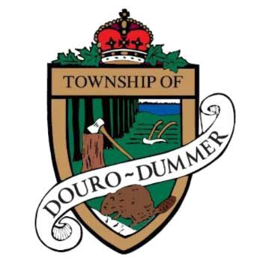

**Township of Douro-Dummer**

**Employment Opportunities in the Public Works Department**

**Two (2) Seasonal Equipment Operator - $28.83 per hour**

The Township of Douro-Dummer is currently seeking two (2) skilled and motivated **Seasonal Equipment Operators** to join our Public Works Department.

**Position Summary:**  
As a Seasonal Equipment Operator, you will be responsible for a wide range of maintenance and construction services throughout the Township. From operating graders, loaders, and backhoes to maintaining roads and municipal facilities.

**Key Responsibilities:**

* Operate heavy equipment for road construction and maintenance, including snow removal and ditching.
* Maintain safe road conditions through sanding, salting, and plowing.
* Conduct general maintenance such as culvert repair, grass cutting, sign installation, and roadside brushing.
* Assist with maintenance at closed waste sites, the transfer station, parks, and municipal buildings.
* Perform routine inspections and light mechanical maintenance of equipment.
* Uphold all health and safety standards and policies.

**Qualifications:**

* Grade 12 education or equivalent.
* Minimum 3 years of experience in road construction and maintenance.
* Valid Class “A” driver’s license with “Z” endorsement and a clean abstract.
* Proven ability to operate various construction and maintenance equipment safely and efficiently.
* Strong teamwork, communication, and customer service skills.
* Comfortable with mobile technology and Microsoft Office tools.
* Certifications or ability to obtain: WHMIS, First Aid, Chainsaw Safety, Surface Miner Common Core, and more.

**Work Conditions:**

* Physically demanding outdoor work in all weather conditions.
* Must be available to work extended or irregular hours as needed.
* PPE must be worn as required.

**Why Join Us?**  
As part of the Douro-Dummer team, you’ll enjoy working in a supportive environment where your skills make a tangible impact on the community. We value safety, teamwork, and dedication, and we’re looking for someone who shares those values.

**How to Apply:**  
Interested candidates are invited to submit their resume and cover letter to hr@dourodummer.ca by Friday, May 2nd, 2025.